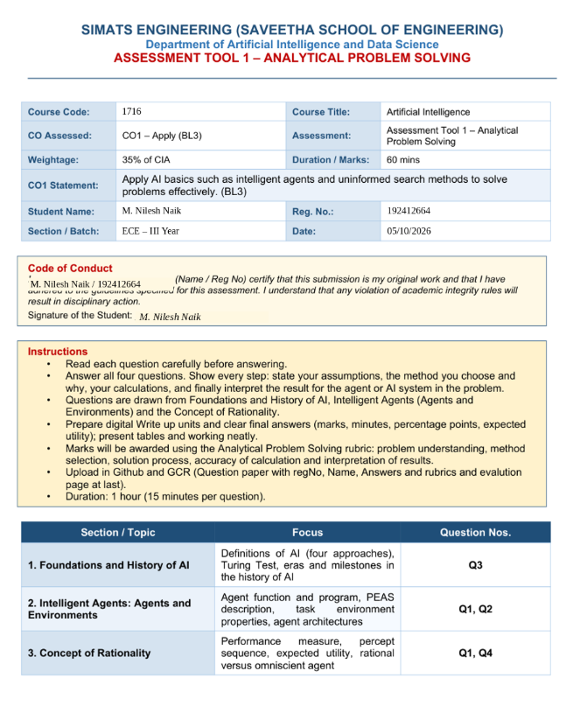

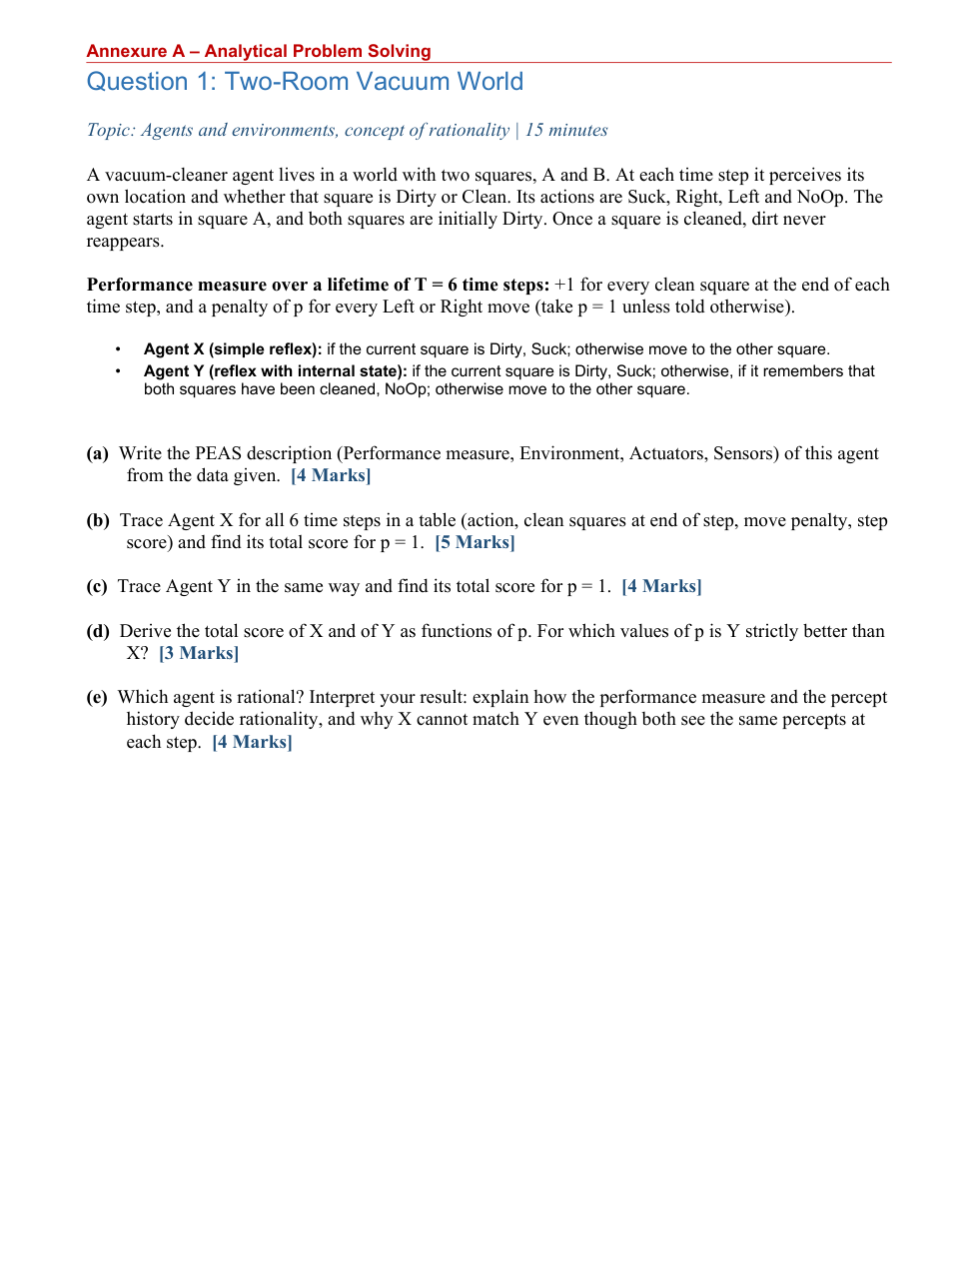

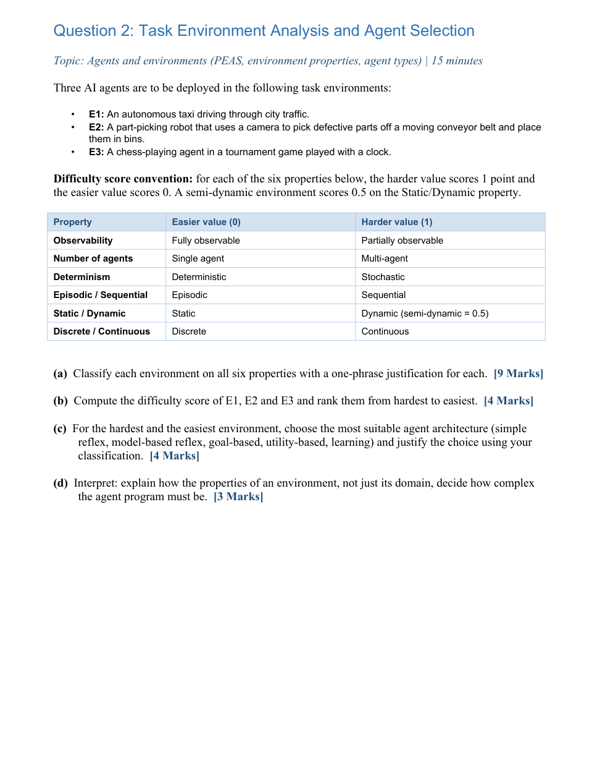

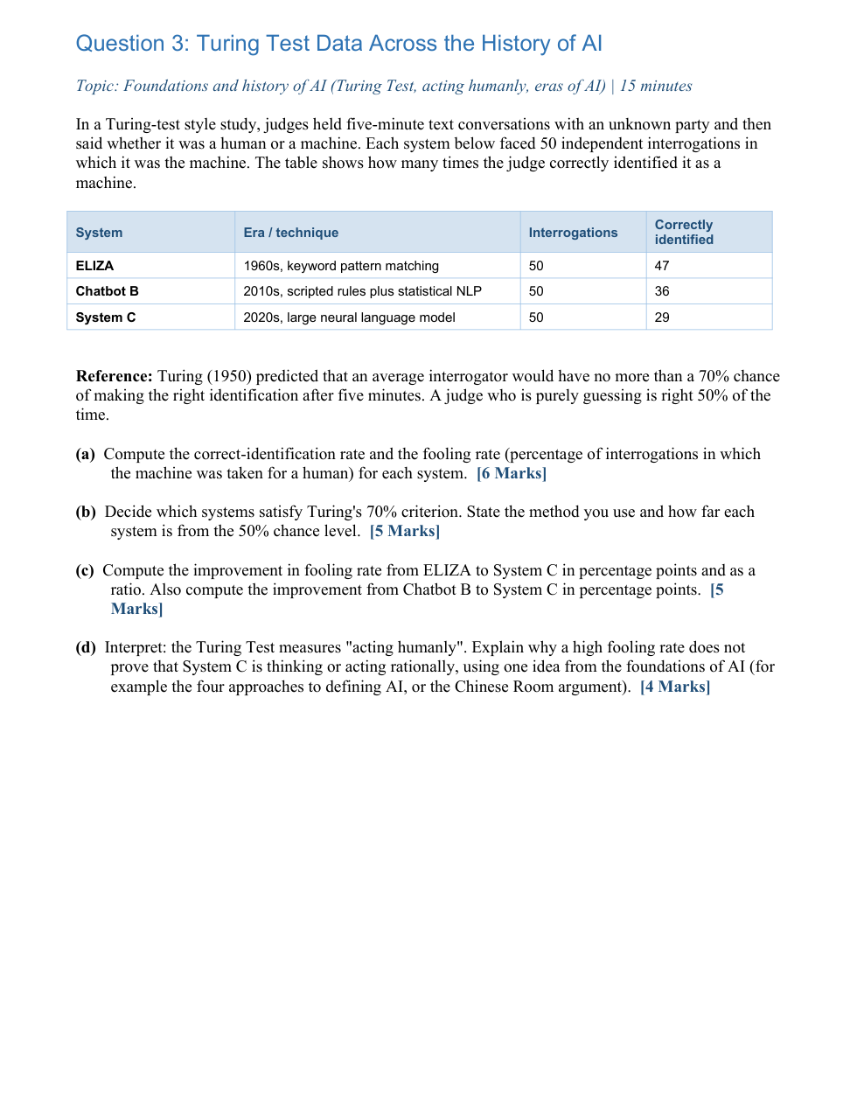

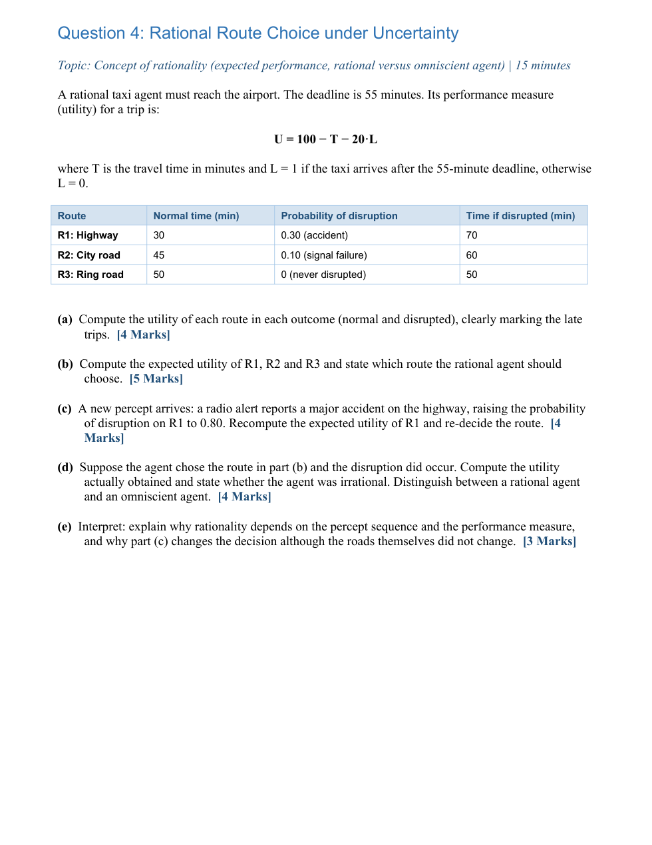

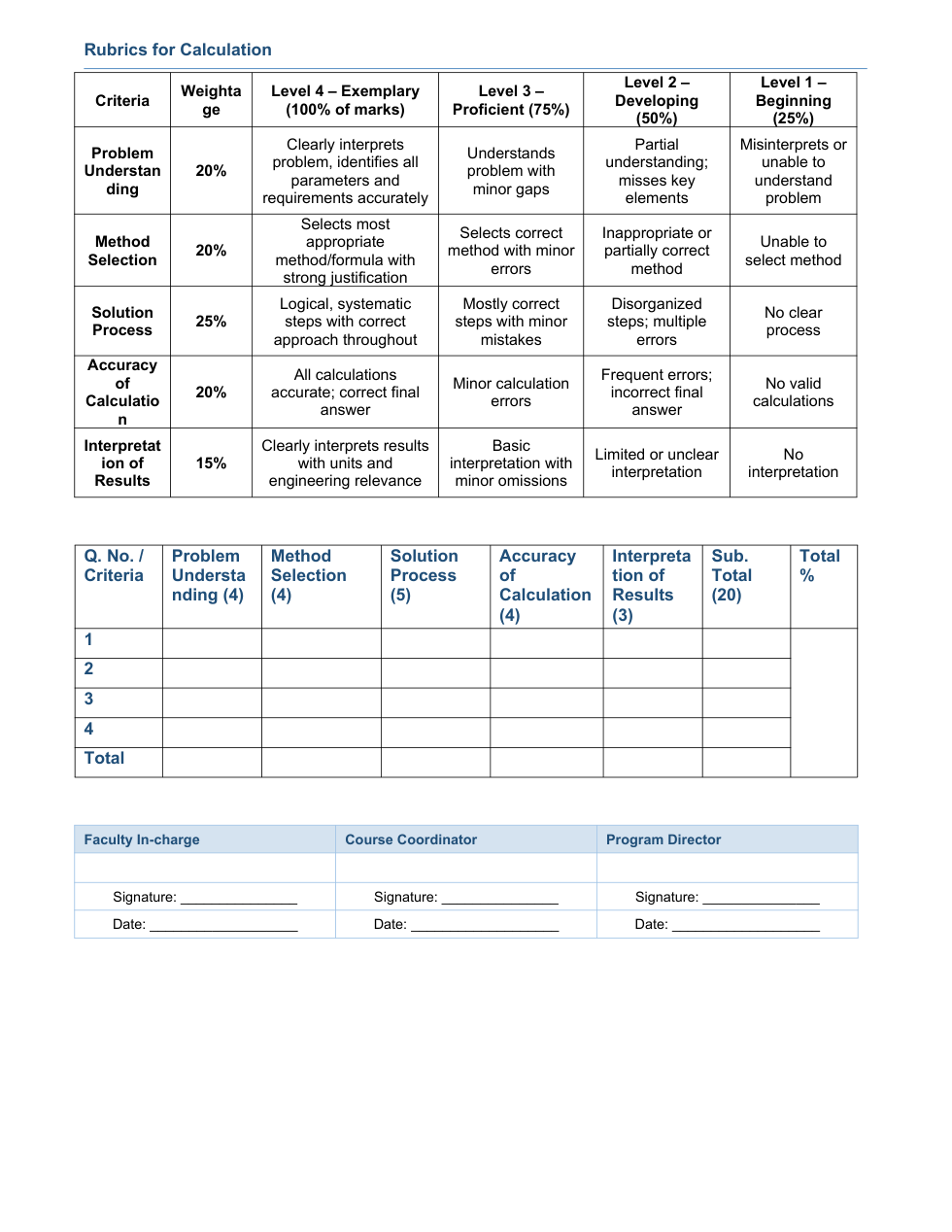
Student Name | M. Nilesh Naik
Reg. No. | 192412664
Section / Batch | ECE – III Year
Date / Course Code | 05/10/2026 / 1716
ANSWER SHEET
SIMATS ENGINEERING (SAVEETHA SCHOOL OF ENGINEERING)
Department of Artificial Intelligence and Data Science
ASSESSMENT TOOL 1 – ANALYTICAL PROBLEM SOLVING
Course Code | 1716 | Course Title | Artificial Intelligence
CO Assessed | CO1 – Apply (BL3) | Assessment | Assessment Tool 1 – Analytical Problem Solving
Weightage | 35% of CIA | Duration / Marks | 60 minutes
Student Name: M. Nilesh NaikM. Nilesh Naik | M. Nilesh Naik | Reg. No.: 192412664192412664 | 192412664
Section / Batch: ECE – III YearECE – III Year | ECE – III Year | Date: 05/10/202605/10/2026 | 05/10/2026
Code of Conduct
I M. Nilesh Naik, 192412664 certify that this submission is my original work and that I have adhered to the guidelines specified for this assessment. I understand that any violation of academic integrity rules will result in disciplinary action.
Signature of the Student: ______________________________
Assessment Instructions
- Answer all four questions and show assumptions, method selection, calculations and interpretation.
- The assessment covers Foundations and History of AI, Intelligent Agents and Environments, and the Concept of Rationality.
- Present calculations, tables and diagrams neatly. The evaluation emphasizes problem understanding, method selection, solution process, calculation accuracy and interpretation.
- Submission requirement: question paper with registration number, name, answers, rubrics and evaluation page.
Topic Coverage
Section / Topic | Focus | Question Nos.
1. Foundations and History of AI | Definitions of AI, Turing Test, eras and milestones | Q3
2. Intelligent Agents: Agents and Environments | Agent function/program, PEAS, task environment, agent architectures | Q1, Q2
3. Concept of Rationality | Performance measure, percept sequence, expected utility, rational vs. omniscient agent | Q1, Q4

Question 1: Two-Room Vacuum World
Problem statement: A vacuum-cleaner agent operates in two squares, A and B. It perceives its location and whether the current square is Dirty or Clean. Its actions are Suck, Right, Left and NoOp. It starts in A; both squares are initially Dirty. Dirt never reappears. The lifetime is T = 6 time steps. The performance measure gives +1 for every clean square at the end of each step and subtracts p for every Left/Right move, with p = 1 unless otherwise stated.

(a) PEAS Description
PEAS element | Answer
Performance | Maximize clean squares at the end of each time step; subtract p = 1 for every Left/Right move.
Environment | Two-room vacuum world with squares A and B; initially both Dirty; dirt does not reappear.
Actuators | Suck, Left, Right and NoOp.
Sensors | Sensor for current location (A/B) and current-square status (Dirty/Clean).
(b) Agent X – Simple Reflex Trace
Method: Apply Agent X's rule directly at every step: if the current square is Dirty, Suck; otherwise move to the other square. The score for each step is the number of clean squares minus the move penalty.
Step | Location / percept | Action | Clean squares at end | Move penalty | Step score
1 | A, Dirty | Suck | 1 | 0 | 1
2 | A, Clean | Right | 1 | 1 | 0
3 | B, Dirty | Suck | 2 | 0 | 2
4 | B, Clean | Left | 2 | 1 | 1
5 | A, Clean | Right | 2 | 1 | 1
6 | B, Clean | Left | 2 | 1 | 1
Total |  |  |  | 3 | 6
Therefore, Agent X total score for p = 1 is 1 + 0 + 2 + 1 + 1 + 1 = 6.
(c) Agent Y – Reflex with Internal State
Method: Agent Y uses the same percepts but stores whether both squares have already been cleaned. Once both are known to be clean, it chooses NoOp rather than continuing to move.
Step | Location / percept | Internal knowledge | Action | Clean squares | Move penalty | Step score
1 | A, Dirty | A not yet clean | Suck | 1 | 0 | 1
2 | A, Clean | A clean; B not yet clean | Right | 1 | 1 | 0
3 | B, Dirty | Both clean after action | Suck | 2 | 0 | 2
4 | B, Clean | Both clean | NoOp | 2 | 0 | 2
5 | B, Clean | Both clean | NoOp | 2 | 0 | 2
6 | B, Clean | Both clean | NoOp | 2 | 0 | 2
Total |  |  |  |  | 1 | 9
Therefore, Agent Y total score for p = 1 is 1 + 0 + 2 + 2 + 2 + 2 = 9.
(d) Scores as Functions of p
Agent X makes three moves (steps 2, 4 and 5/6 pattern gives three Right/Left moves in the six-step horizon), while its clean-square contributions sum to 10. Hence S_X(p) = 10 − 3p. Agent Y makes only one move (step 2), while its clean-square contributions also sum to 10. Hence S_Y(p) = 10 − p.
Y is strictly better when 10 − p > 10 − 3p, giving 2p > 0, so Y is strictly better for p > 0. At p = 0 the two agents tie.
(e) Rationality Interpretation
Agent Y is rational under the stated performance measure because it cleans both squares and then avoids unnecessary movement penalties. The percept history matters: after observing and cleaning both rooms, Y remembers that no further cleaning is required. Agent X is memoryless; when it sees a Clean square it cannot use past percepts to know that the other square is also clean, so it keeps moving and loses utility. Thus, even with identical current percepts, an internal state can support a more rational action.
Final Q1 result: Agent Y is the better rational agent for every positive movement penalty p.

Question 2: Task Environment Analysis and Agent Selection
Problem statement: E1 is an autonomous taxi in city traffic; E2 is a camera-based part-picking robot on a moving conveyor; E3 is a chess-playing agent in a timed tournament. Each harder property scores 1, easier scores 0, and a semi-dynamic environment scores 0.5 for Static/Dynamic.
(a) Six-Property Classification
Environment | Observability | Agents | Determinism | Episodic / Sequential | Static / Dynamic | Discrete / Continuous
E1 Taxi | Partially observable – traffic and intent are not fully known | Multi-agent – other drivers | Stochastic – accidents/traffic vary | Sequential – each action affects later states | Dynamic – traffic changes while acting | Continuous – position, speed and time
E2 Conveyor robot | Partially observable – camera/noise/occlusion can hide information | Single agent – one picking robot | Stochastic – belt motion and detection vary | Sequential – picking actions affect subsequent choices | Dynamic – belt keeps moving | Continuous – motion, time and positions
E3 Chess | Fully observable – board state is visible | Multi-agent – two competing players | Deterministic – legal moves have fixed rules | Sequential – moves change future states | Semi-dynamic – clock changes while thinking | Discrete – finite board squares and moves
(b) Difficulty Score and Ranking
Environment | Partial Obs. | Multi-agent | Stochastic | Sequential | Dynamic | Continuous | Total
E1 Taxi | 1 | 1 | 1 | 1 | 1 | 1 | 6
E2 Conveyor robot | 1 | 0 | 1 | 1 | 1 | 1 | 5
E3 Chess | 0 | 1 | 0 | 1 | 0.5 | 0 | 2.5

Ranking from hardest to easiest: E1 (6) > E2 (5) > E3 (2.5).
(c) Agent Architecture Selection
Environment | Recommended architecture | Justification
Hardest: E1 Taxi | Utility-based agent (with learning/model-based components in practice) | The taxi is partially observable, multi-agent, stochastic, sequential, dynamic and continuous. It must trade off safety, travel time and route quality rather than simply achieve one fixed goal.
Easiest: E3 Chess | Goal-based agent | Chess has a discrete, fully observable and deterministic environment. The agent can evaluate legal move sequences against the explicit goal of winning, while the clock makes timely action important.
(d) Interpretation
The domain name alone does not determine agent complexity. Environment properties determine what information the agent receives, how uncertain the outcome is, whether actions have long-term consequences, and whether the world changes during computation. Therefore, a partially observable, stochastic and dynamic environment generally requires memory, prediction and utility-based decision making, whereas a fully observable and discrete environment can support a simpler architecture.

Question 3: Turing Test Data Across the History of AI
Problem statement: Each system faced 50 independent five-minute interrogations while it was the machine. The table reports how many times judges correctly identified it as a machine. Turing's reference criterion is a maximum 70% chance of correct identification by an average interrogator; random guessing gives 50%.
System | Era / technique | Interrogations | Correctly identified
ELIZA | 1960s, keyword pattern matching | 50 | 47
Chatbot B | 2010s, scripted rules plus statistical NLP | 50 | 36
System C | 2020s, large neural language model | 50 | 29
(a) Correct-Identification and Fooling Rates
Formula: Correct-identification rate = (correctly identified / 50) × 100. Fooling rate = 100 − correct-identification rate.
System | Correct identification | Correct rate | Fooling rate
ELIZA | 47/50 | 94% | 6%
Chatbot B | 36/50 | 72% | 28%
System C | 29/50 | 58% | 42%

(b) Turing 70% Criterion and Distance from 50%
Method: Compare each correct-identification rate with the 70% ceiling. A system satisfies the stated criterion when the judge's correct-identification rate is no more than 70%.
System | Correct rate | Satisfies ≤70%? | Distance above 50% guessing level
ELIZA | 94% | No | 44 percentage points
Chatbot B | 72% | No | 22 percentage points
System C | 58% | Yes | 8 percentage points
(c) Fooling-Rate Improvements
ELIZA → System C: 42% − 6% = 36 percentage points. Ratio = 42/6 = 7, so System C's fooling rate is 7 times ELIZA's (a 600% increase relative to ELIZA).
Chatbot B → System C: 42% − 28% = 14 percentage points.
(d) Interpretation: Acting Humanly Is Not the Same as Thinking Rationally
The Turing Test primarily evaluates whether a system can act or communicate in a way that is difficult for a judge to distinguish from a human. A high fooling rate therefore measures behavioral similarity in the test setting, not proof of genuine reasoning, understanding or rational decision making. Under the four-approaches view of AI, “acting humanly” is different from “thinking rationally” and “acting rationally.” The Chinese Room argument further illustrates that producing convincing language behavior does not by itself establish understanding. Therefore, System C's 42% fooling rate does not prove that it thinks or acts rationally.
Final Q3 result: System C performs best on the given Turing-style measure because it has the highest fooling rate (42%) and is the only system meeting the stated ≤70% correct-identification criterion.

Question 4: Rational Route Choice under Uncertainty
Problem statement: A taxi must reach the airport by a 55-minute deadline. Utility is U = 100 − T − 20L, where T is travel time and L = 1 if the taxi arrives after 55 minutes; otherwise L = 0.
Route | Normal time | Disruption probability | Disrupted time
R1: Highway | 30 min | 0.30 | 70 min
R2: City road | 45 min | 0.10 | 60 min
R3: Ring road | 50 min | 0 | 50 min
(a) Utility in Each Outcome
For an on-time trip, L = 0, so U = 100 − T. For a late trip, L = 1, so U = 80 − T.
Route | Outcome | T (min) | Late? L | Utility U
R1 | Normal | 30 | 0 | 70
R1 | Disrupted | 70 | 1 | 10 (LATE)
R2 | Normal | 45 | 0 | 55
R2 | Disrupted | 60 | 1 | 20 (LATE)
R3 | Normal | 50 | 0 | 50
R3 | Disrupted | 50 | 0 | 50 (never late)
(b) Expected Utility and Rational Choice
Formula: EU = (1 − q)U_normal + qU_disrupted, where q is the disruption probability.
Route | Expected-utility calculation | Expected utility
R1 | 0.70(70) + 0.30(10) | 52.0
R2 | 0.90(55) + 0.10(20) | 51.5
R3 | 1.00(50) + 0(50) | 50.0

R1 has the highest expected utility, 52.0. Therefore, the rational agent should initially choose R1: Highway.
(c) Updated Percept: Highway Accident Alert
The new percept raises R1's disruption probability from 0.30 to 0.80. Thus EU(R1) = 0.20(70) + 0.80(10) = 14 + 8 = 22.0.
R2 remains at 51.5 and R3 remains at 50.0. Therefore, after the new percept, the rational choice changes from R1 to R2.
(d) Actual Outcome and Rational vs. Omniscient Agent
In part (b), the agent rationally chose R1 because it had the highest expected utility before the new accident information. If the disruption then occurs, the actual utility is U = 100 − 70 − 20(1) = 10.
The agent was not irrational: rationality is evaluated using the information available before acting, not by demanding perfect hindsight. An omniscient agent would know the actual future outcome in advance and could avoid the disrupted highway, choosing the route with the best known realized utility. Thus, a rational agent maximizes expected performance from its percept sequence, whereas an omniscient agent has information about the true future state that an ordinary agent does not possess.
(e) Interpretation
Rationality depends on both the percept sequence and the performance measure. The performance measure assigns a large penalty to arriving late, so the probability of disruption matters strongly. In part (c), the roads did not physically change; the agent's information changed because the radio alert increased the estimated probability of an accident. Consequently, the expected utilities changed and the rational decision changed from R1 to R2.
Final Q4 result: Before the alert choose R1 (EU = 52.0); after the alert choose R2 (EU = 51.5 versus R1 = 22.0).

Rubrics for Calculation and Evaluation
Criteria | Weightage | Level 4 – Exemplary (100%) | Level 3 – Proficient (75%) | Level 2 – Developing (50%) | Level 1 – Beginning (25%)
Problem Understanding | 20% | Clearly interprets problem; identifies all parameters and requirements accurately | Understands problem with minor gaps | Partial understanding; misses key elements | Misinterprets or unable to understand problem
Method Selection | 20% | Selects most appropriate method/formula with strong justification | Selects correct method with minor errors | Inappropriate or partially correct method | Unable to select method
Solution Process | 25% | Logical, systematic steps with correct approach throughout | Mostly correct steps with minor mistakes | Disorganized steps; multiple errors | No clear process
Accuracy of Calculation | 20% | All calculations accurate; correct final answer | Minor calculation errors | Frequent errors; incorrect final answer | No valid calculations
Interpretation of Results | 15% | Clearly interprets results with units and engineering relevance | Basic interpretation with minor omissions | Limited or unclear interpretation | No interpretation
Evaluation Page
Q. No. / Criteria | Problem Understanding (4) | Method Selection (4) |  | Solution Process (5) | Accuracy of Calculation (4) | Interpretation of Results (3) |  | Sub. Total (20) | Total %
1
2
3
4
Total
Faculty In-charge |  |  | Course Coordinator |  |  |  | Program Director
Signature: __________________ |  |  | Signature: __________________ |  |  |  | Signature: __________________
Date: 05/10/202605/10/2026 |  |  | Date: 05/10/202605/10/2026 |  |  |  | Date: 05/10/202605/10/2026

